**Brigada Verdão**

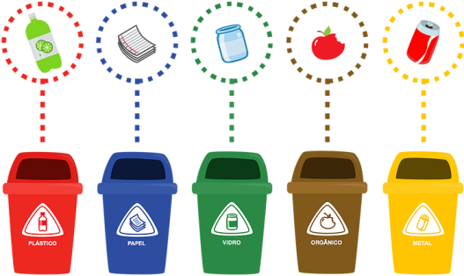Se o planeta queres ajudar,

O lixo deves separar.

O papel no azul,

O vidro no verde

E o plástico no amarelo

Deves colocar.

Eco-escolas vai-te ajudar a reciclar.

Grelha de monitorização dos eco-bags das salas

**Assinala com MB, B, Suf, Insuf, correspondente à correta separação dos resíduos na sala de aula.**

|  |  |  |  |  |  |  |  |  |  |  |  |  |  |  |  |  |  |  |  |  |
| --- | --- | --- | --- | --- | --- | --- | --- | --- | --- | --- | --- | --- | --- | --- | --- | --- | --- | --- | --- | --- |
| **Sala** | **Janeiro** | | | | **Fevereiro** | | | | **Março** | | | | **Abril** | | | | **Maio** | | | |
| 1 | MB | B | Suf | Insuf | MB | B | Suf | Insuf | MB | B | Suf | Insuf | MB | B | Suf | Insuf | MB | B | Suf | Insuf |
| 2 | MB | B | Suf | Insuf | MB | B | Suf | Insuf | MB | B | Suf | Insuf | MB | B | Suf | Insuf | MB | B | Suf | Insuf |
| 3 | MB | B | Suf | Insuf | MB | B | Suf | Insuf | MB | B | Suf | Insuf | MB | B | Suf | Insuf | MB | B | Suf | Insuf |
| 4 | MB | B | Suf | Insuf | MB | B | Suf | Insuf | MB | B | Suf | Insuf | MB | B | Suf | Insuf | MB | B | Suf | Insuf |
| 5 | MB | B | Suf | Insuf | MB | B | Suf | Insuf | MB | B | Suf | Insuf | MB | B | Suf | Insuf | MB | B | Suf | Insuf |
| 6 | MB | B | Suf | Insuf | MB | B | Suf | Insuf | MB | B | Suf | Insuf | MB | B | Suf | Insuf | MB | B | Suf | Insuf |
| 7 | MB | B | Suf | Insuf | MB | B | Suf | Insuf | MB | B | Suf | Insuf | MB | B | Suf | Insuf | MB | B | Suf | Insuf |
| 8 | MB | B | Suf | Insuf | MB | B | Suf | Insuf | MB | B | Suf | Insuf | MB | B | Suf | Insuf | MB | B | Suf | Insuf |
| 9 | MB | B | Suf | Insuf | MB | B | Suf | Insuf | MB | B | Suf | Insuf | MB | B | Suf | Insuf | MB | B | Suf | Insuf |
| 10 | MB | B | Suf | Insuf | MB | B | Suf | Insuf | MB | B | Suf | Insuf | MB | B | Suf | Insuf | MB | B | Suf | Insuf |
| 11 | MB | B | Suf | Insuf | MB | B | Suf | Insuf | MB | B | Suf | Insuf | MB | B | Suf | Insuf | MB | B | Suf | Insuf |
| 12 | MB | B | Suf | Insuf | MB | B | Suf | Insuf | MB | B | Suf | Insuf | MB | B | Suf | Insuf | MB | B | Suf | Insuf |
| 13 | MB | B | Suf | Insuf | MB | B | Suf | Insuf | MB | B | Suf | Insuf | MB | B | Suf | Insuf | MB | B | Suf | Insuf |
| 14 | MB | B | Suf | Insuf | MB | B | Suf | Insuf | MB | B | Suf | Insuf | MB | B | Suf | Insuf | MB | B | Suf | Insuf |
| 15 | MB | B | Suf | Insuf | MB | B | Suf | Insuf | MB | B | Suf | Insuf | MB | B | Suf | Insuf | MB | B | Suf | Insuf |
| 16 | MB | B | Suf | Insuf | MB | B | Suf | Insuf | MB | B | Suf | Insuf | MB | B | Suf | Insuf | MB | B | Suf | Insuf |
| 17 | MB | B | Suf | Insuf | MB | B | Suf | Insuf | MB | B | Suf | Insuf | MB | B | Suf | Insuf | MB | B | Suf | Insuf |
| 18 | MB | B | Suf | Insuf | MB | B | Suf | Insuf | MB | B | Suf | Insuf | MB | B | Suf | Insuf | MB | B | Suf | Insuf |